# Login page implementation:

1.First go to login component.ts file create variables with username and password example.



2.Now create a function in login component.ts file .

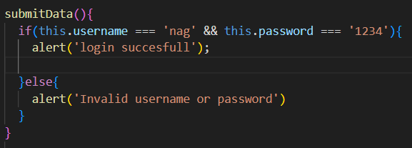

3. Now go to login component.html file, in form element Call the login ts file function (submitData).



4. Now go to login component.html file bind the username and password In same input fields. i.e(username in user input and password in password input field). And also add required.



5.Now create a constructor in login ts file and pass parameter as router.



6. Now go to login component.ts file, call router.navigate in already created function i.e(submitData).When login is success it directly goes to dashboard.

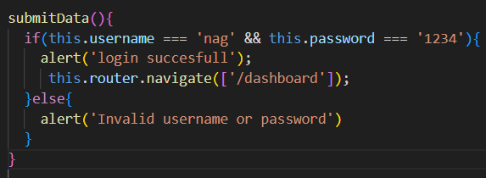

# Logout Implementation:

1. Now go to home component.ts file. i.e where routerlinks are included in that file. Create a constructor and pass a router in it.



2.Now create a function in home component.ts file for navigation to redirect to login page when click on logout.

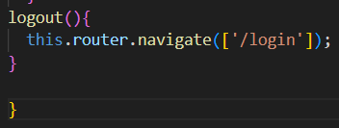

1. Now go to home component.html file. create a button.



4.Now go to home component.html, call the ts file function (logout) in button.

